LoginScenario_TestForInvalidLogin_Instance6_15-Feb-2016_06-01-08_PM_Enter_user_credentials.png

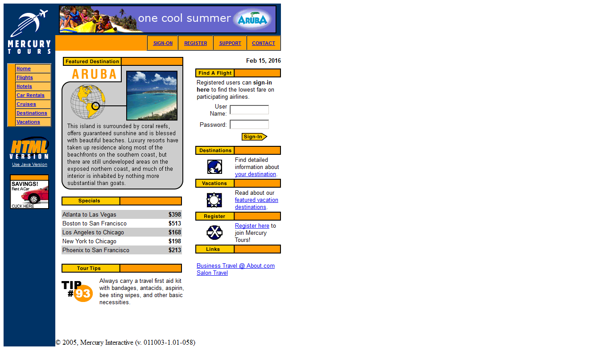

LoginScenario_TestForInvalidLogin_Instance6_15-Feb-2016_06-01-08_PM_Login.png

